MAD CEP

20SW030
20SW060

Real world problem:
Event planning has been named the 5th most stressful job in the
world. 85% of projects go above budget. when we plan everything
on our own without any experience and knowledge. So a good
event planner is needed for every event And what if you don’t
know any event planners in your area? here our Application Bliss
comes in handy it picks the best event planner for you based on
your needs.

Solution:
Bliss is the smarter way to plan events and connect with the best planners. Our app allows you to instantly search, compare and book local planners based on expertise, styles and pricing. No more endless hours googling different vendors. No more phone calls back and forth. No more uncertainty if you made the right hire. With Bliss, quickly browse planner profiles, reviews, and real examples of their events. Chat with them in-app to get quotes and discuss your vision. Hire seamlessly when you find the perfect match. For planners, Bliss provides the platform to easily showcase their services, connect with clients, and reduce admin hassle - leading to more bookings.

ScreenShots:

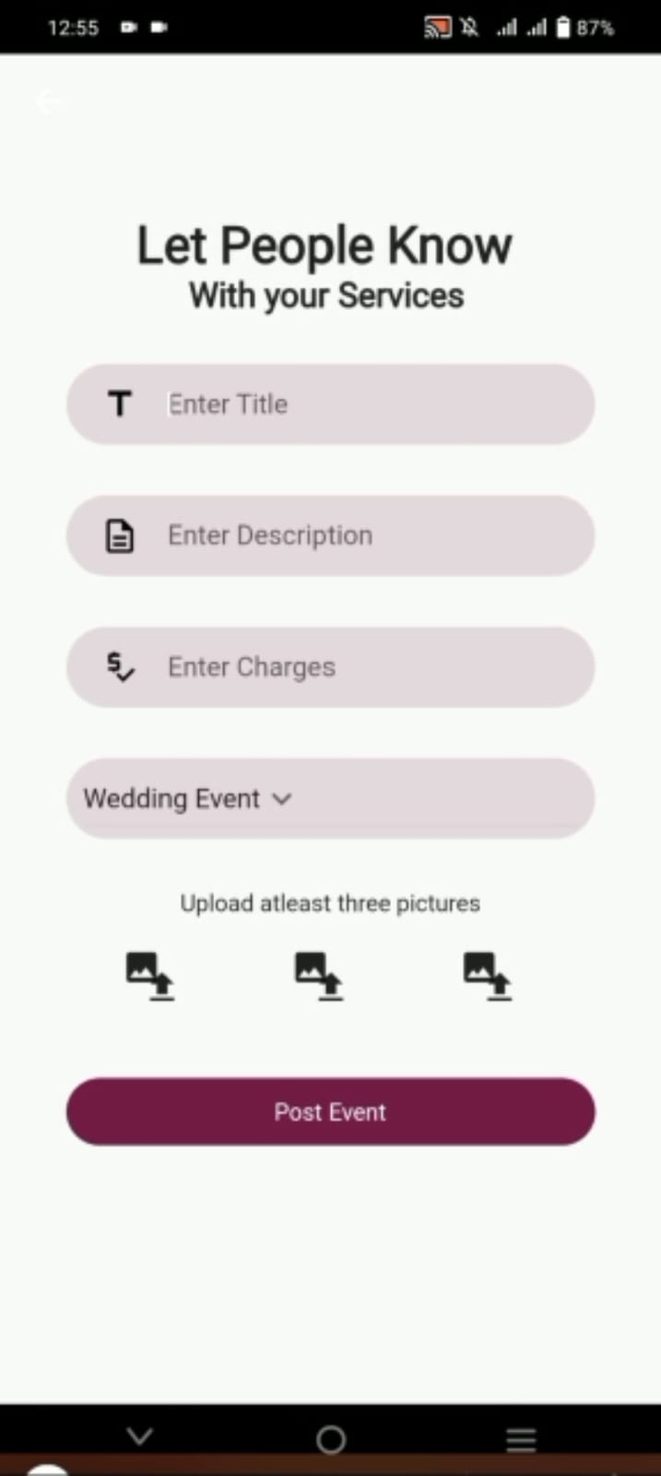
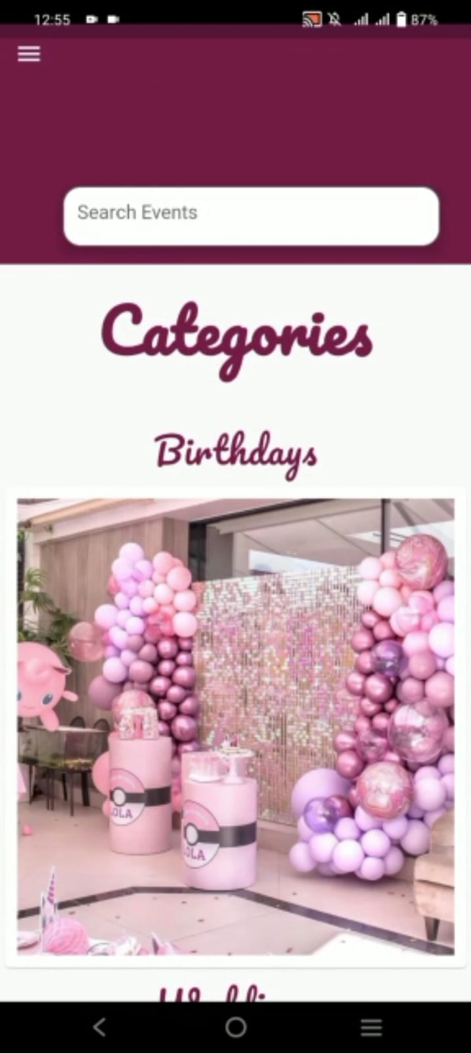
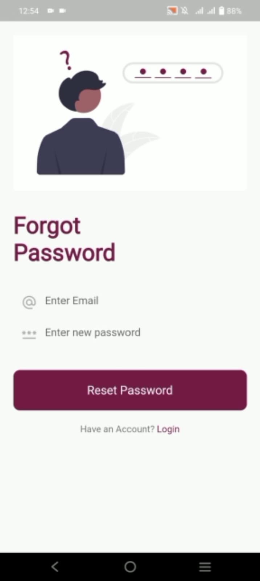

DATABASE:
Real-time database - Firebase provides a realtime NoSQL cloud database that syncs data across all clients in realtime. This allows changes by users, such as event planner profiles, availability, and bookings to be reflected instantly across the app. This ensures all users see accurate, up-to-date information. Being a cloud-hosted database, Firebase scales up automatically to store increasing amounts of data like user profiles, events, ratings etc as the app grows. There are no limits on storage size or bandwidth.

Issues and Bugs:
Issues:
• Connecting to Firebase - Initial setup and integrating the Firebase SDKs into the app required resolving dependencies and installation issues. This was fixed by following Firebase documentation and getting the config files correct.
• Uploading images - Enabling image uploads for event galleries and planner profiles required configuring storage rules and permissions in Firebase correctly. Resolved by allowing read/write access.
• Realtime data sync - Getting realtime sync working for updating event details or user bookings required proper structuring of the Firebase database and indexing. Solved by structuring data under logical nodes.
Bugs:
• Login issues - Incorrect credentials or forgot password flows were buggy initially. Fixed by properly handling auth state changes and edge cases.
• Bugs during account creation - The sign-up flow had multiple bugs that would surface for some user inputs. Added better input validation and error handling to smooth out account creation.
• Post event screen crashing - When users tried to open the navigation drawer while filling out the event posting screen, the app would crash. This occurred because we were not handling the state correctly when transitioning between the drawer and posting screens.

